Pset 7

ISIM Fall 2019

Lilo Heinrich

**Open loop behavior:**

1. Figure 5.3 – Triangle Wave

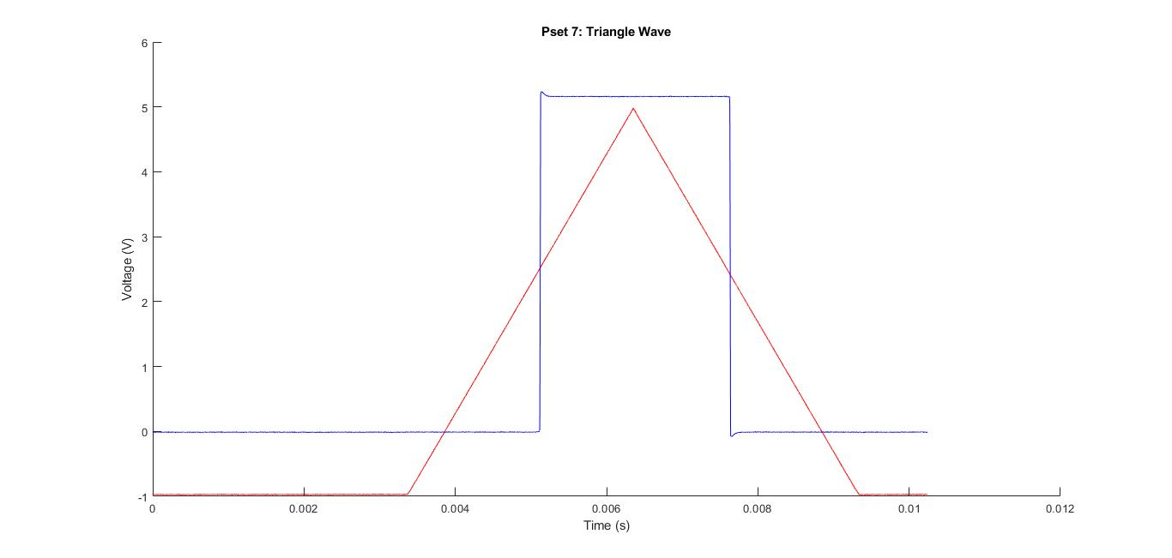

1. Figure 5.4 – Sine Wave

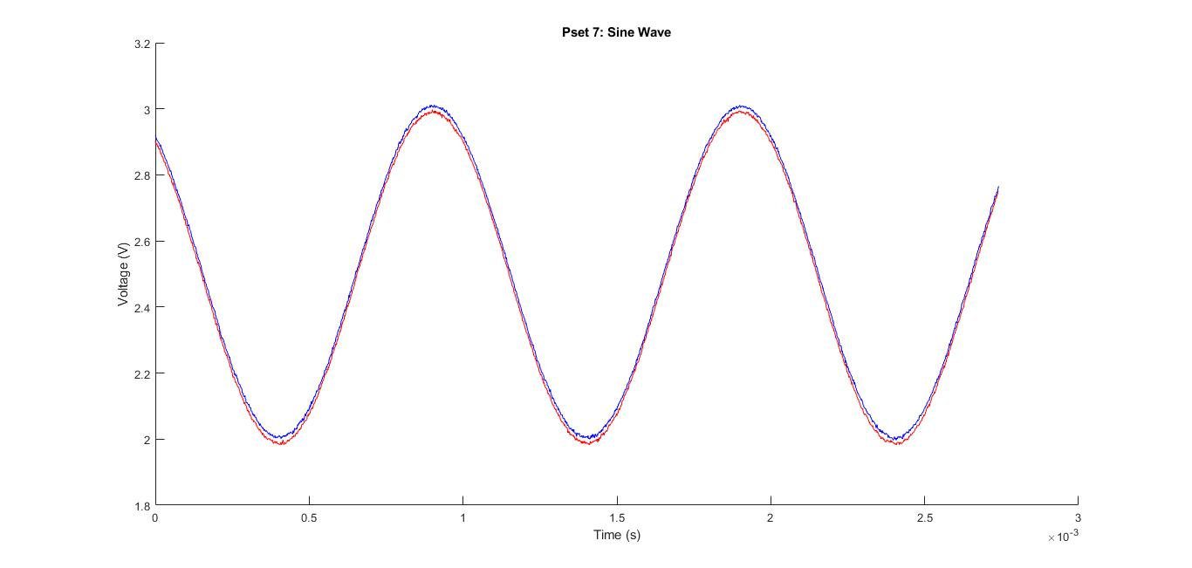

**Op-amp voltage follower:**

3. Yes, although it lags behind slightly, taking a very short amount of time to catch up to the input signal.

4. The lag between the follower and the input becomes strongly apparent around 500 kHz, although I’m sure that if I zoom in to a much shorter time interval and use very sensitive equipment, it would become apparent that there is some amount of “catch-up time” no matter what frequency is set.

5. It takes approximately 1 µs for the op amp output to oscillate and then settle to follow the input signal with a 1 kHz square wave.

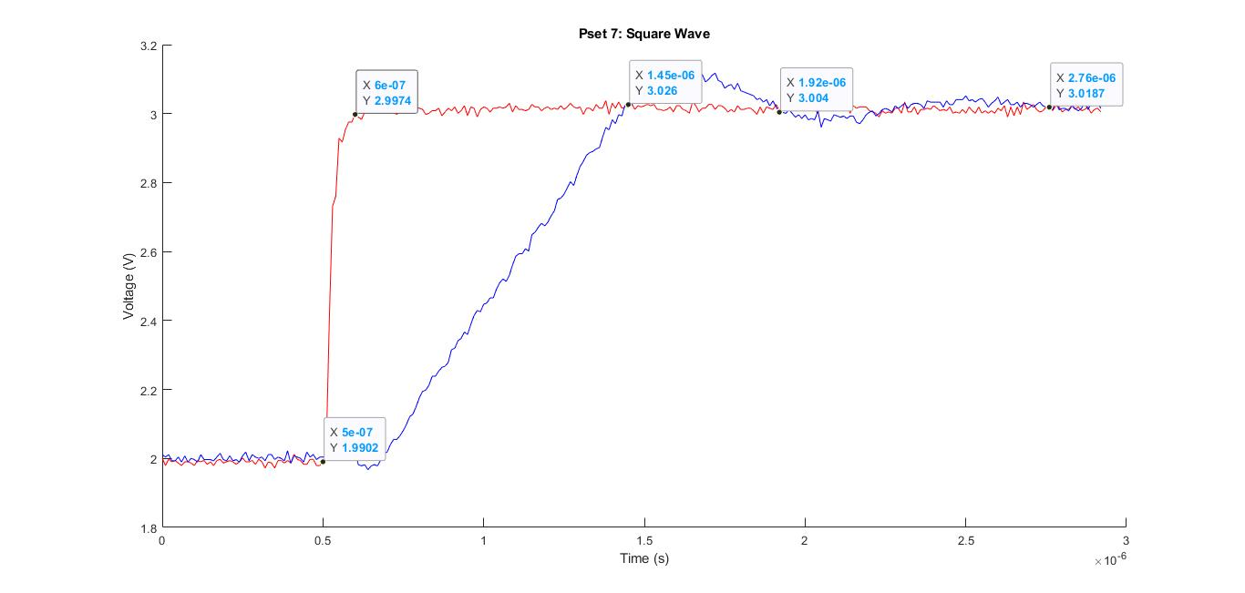

6. A 1 kHz sine wave of amplitude = 1 V, centered about 0 V doesn’t work for this circuit because it contains negative voltage values. The op amp can only output within the range of V+ to V-, which in this case is 0 to 5 V. Therefore, it cannot output below 0, cutting off the wave.

7. The positive feedback circuit does not work as a follower because it will converge to 2.5 V, the negative input. This is not useful information.

**Follower as a buffer:**

V without follower (Va): 1.75 V

V with follower (Vb): 2.59 V

Since the analog discovery measures between the voltage divider output point and ground and has an impedance of about 2 MHz, although the voltage divider output should be ~2.5 V, it reads as 1.75 V due to the analog discovery absorbing some of it. With the voltage follower in place, the ability of the analog discovery to act as a parallel resistor is fixed, due to the output of the follower producing only a very, very small or nonexistent current.